15/07/2023

INSTRUCTION DOCUMENT

Data Engineering Assignment

# Pre-requisite

* Install Docker
* Install Airflow
* Install Terraform
* Install visual studio code.
* Make Google cloud ID.

# Steps

* Project Name: ‘**My First Project’**
* Project ID: **'seismic-vista-391518'**
* Create the project with above name in GCP. For setting up GCP please refer the slide Airflow deep dive.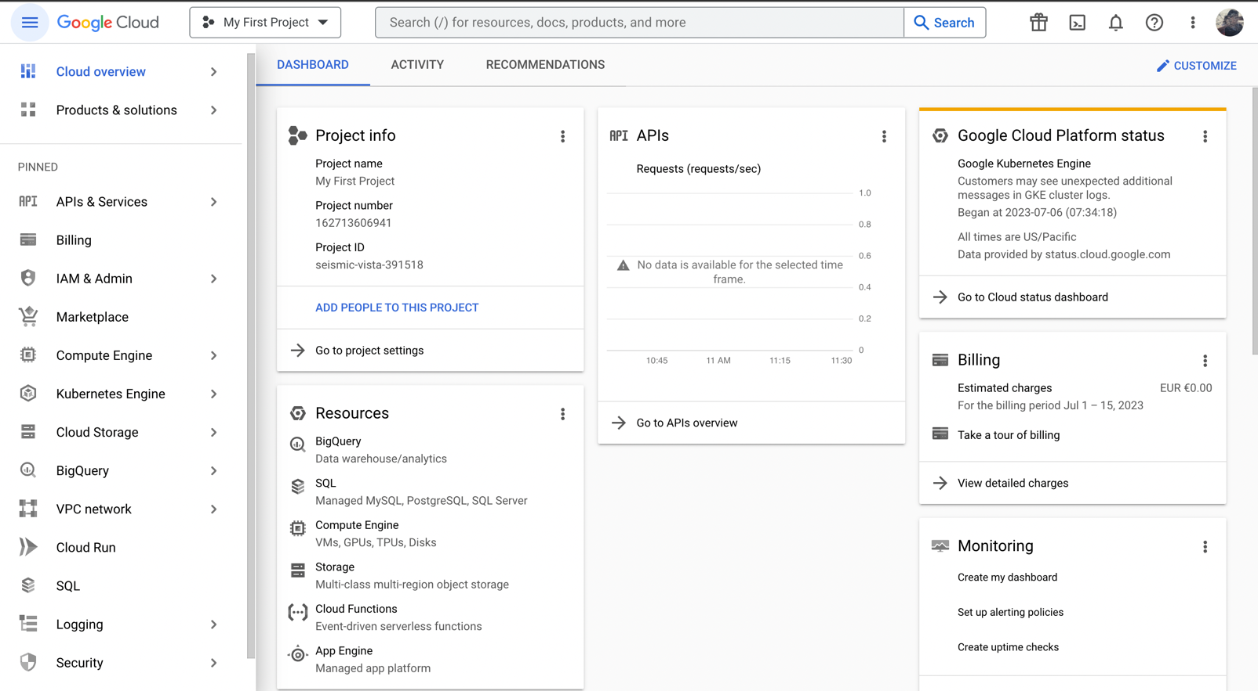
* Setup the service account inside the project **'seismic-vista-391518'** GCP please refer the slide Airflow deep dive.
* Create and download the security key **.Json file**. and save it inside .google folder of airflow

intro folder

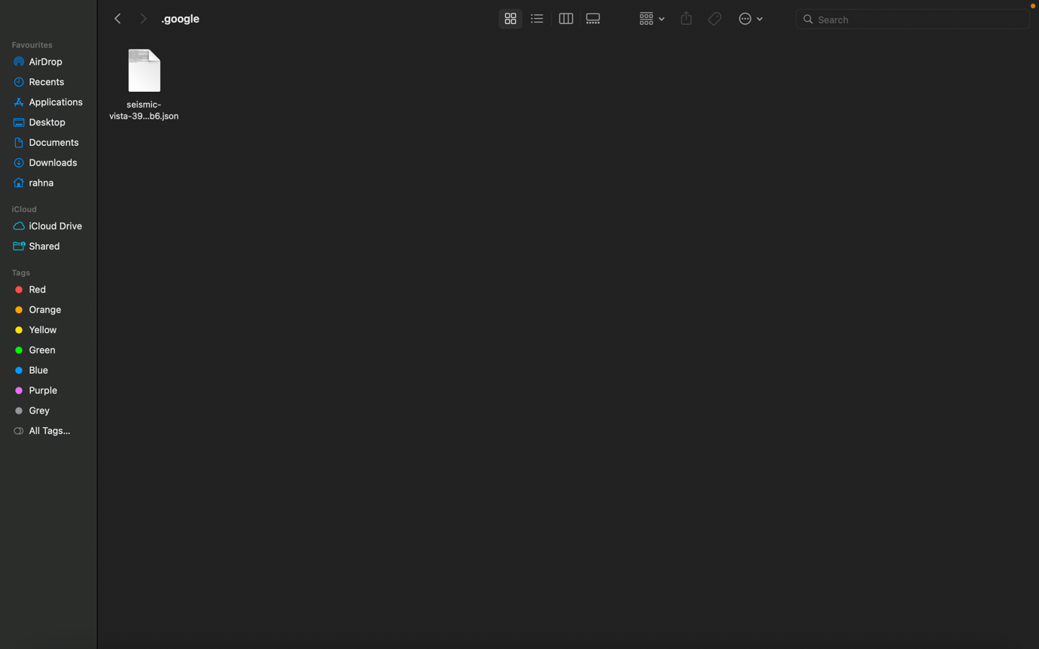

* Copy and Unzip the **Terraform.zip** to local and copy it to necessary drive.
* Copy the **.Json file** to following folder location.

## ~ \Terraform

* Copy and Unzip the **airflow_intro.zip** to local and copy it to necessary drive.
* Copy the **.Json file** to following folder location.

## ~\airflow_intro\.google

* Open vs code and export the **Terraform** root folder and **airflow_intro** folder to workspace.

## Setting up infrastructure in Google Cloud using terraform

* Open **main.tf** file replace the .json file name with new security key file name.
* Open **variable.tf** file replace the project id with reviewer’s project id.

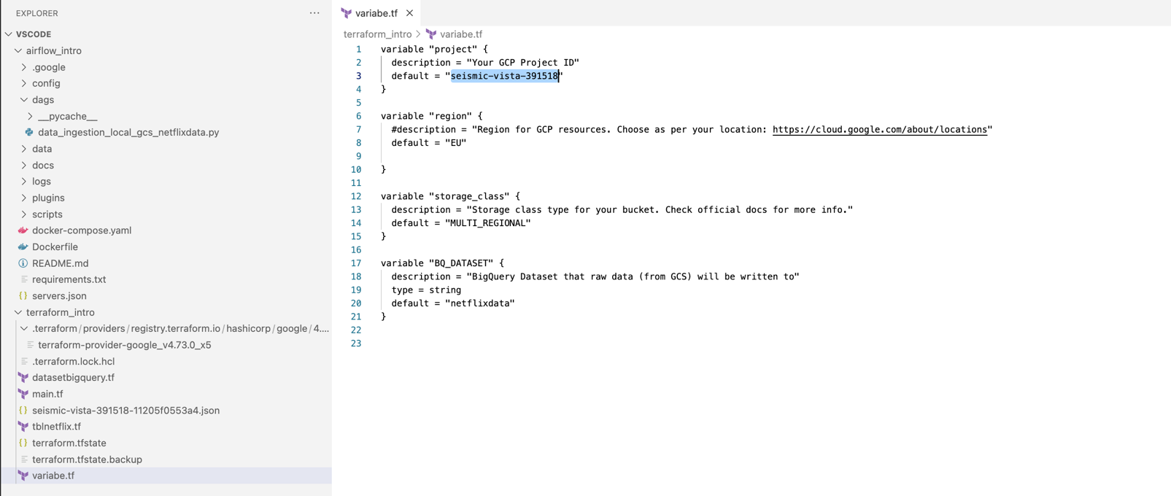

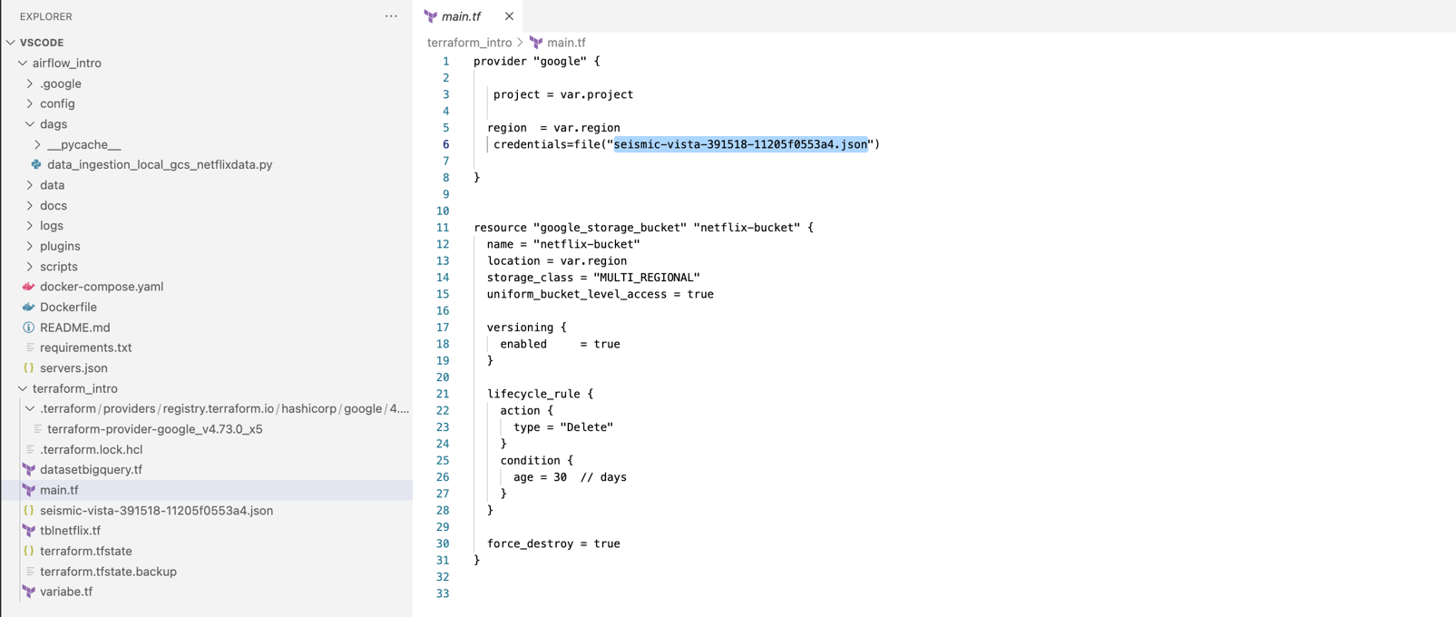

* In vs code open command terminal in Terraform directory and execute below commands

## terraform init terraform apply

* This will create data lake bucket and data warehouse dataset in Google Cloud Project

**‘My First Project’** with following name.

BUCKET: **netflix-bucket**

DATASET: **911dataset**

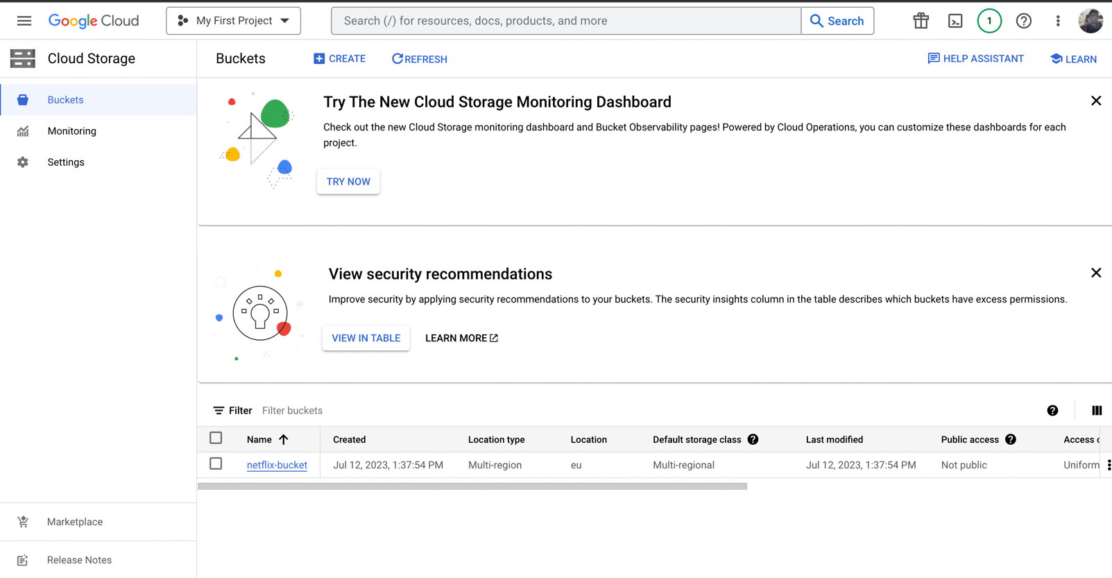

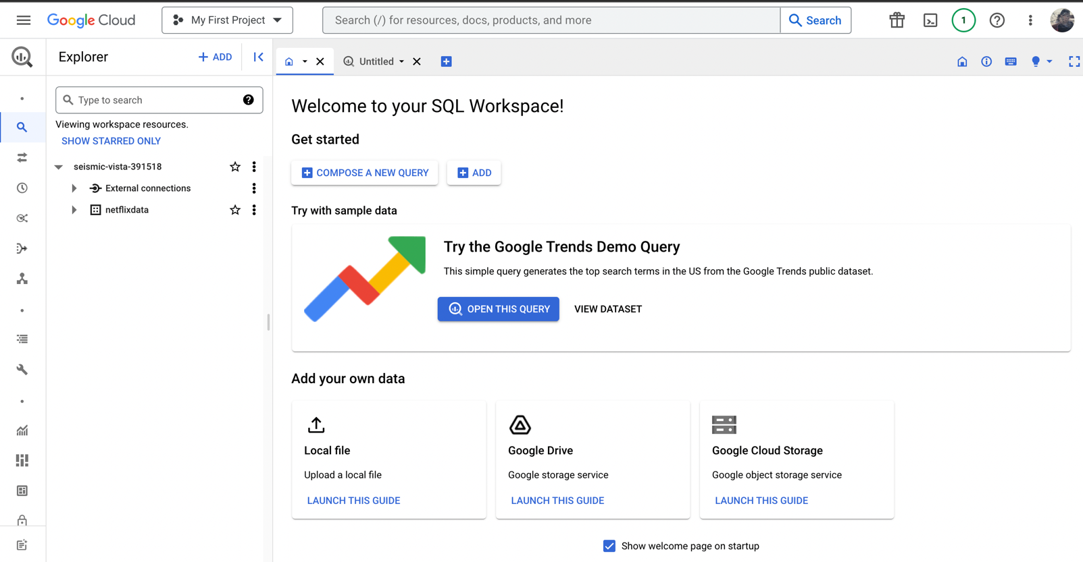

* Open **docker-compose.yaml** file in vs code from **airflow_intro directory** and replace the

.json file name with new security key file name in 2 places.

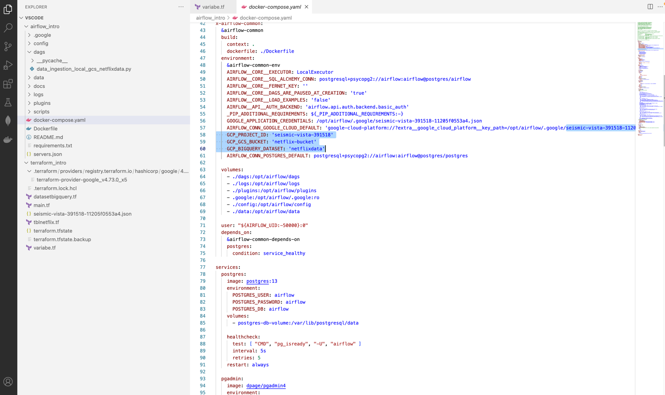

* Open new terminal at **airflow_intro directory** in vs code then trigger the below command

**-> docker-compose build**

**-> docker-compose up airflow-init**

**-> docker-compose up**

* Open docker desktop and check for the new image of **"airflow_intro”** make sure every task under it is running, if not select everything and run
* 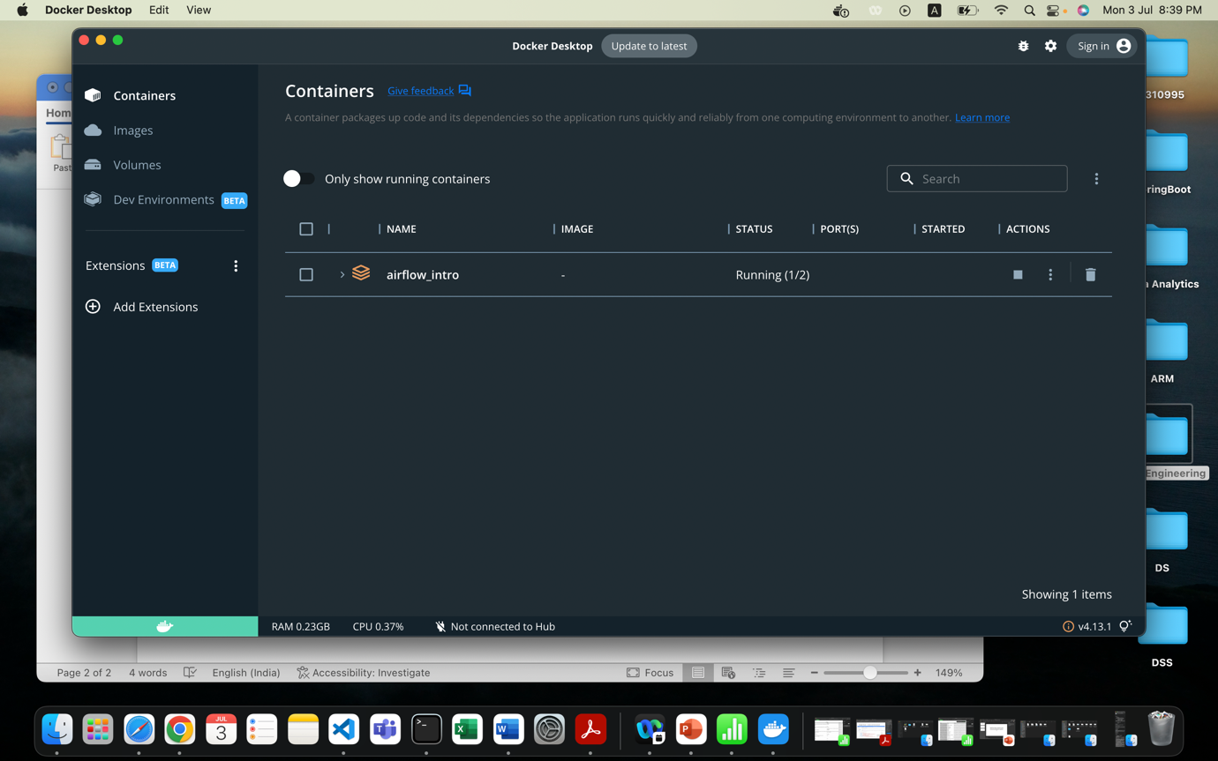

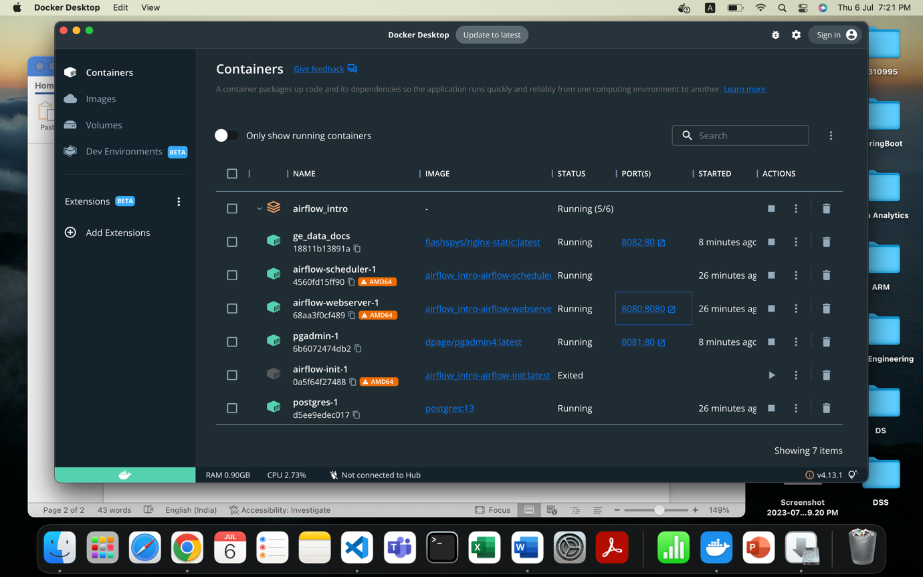

* Click on the **airflow webserver link**, will direct you to http://localhost:8080/ airflow page.
* Sign In and check for the below DAG name **“data_ingestion_local_gcs_netflix”**
* Trigger the data and wait for completion.

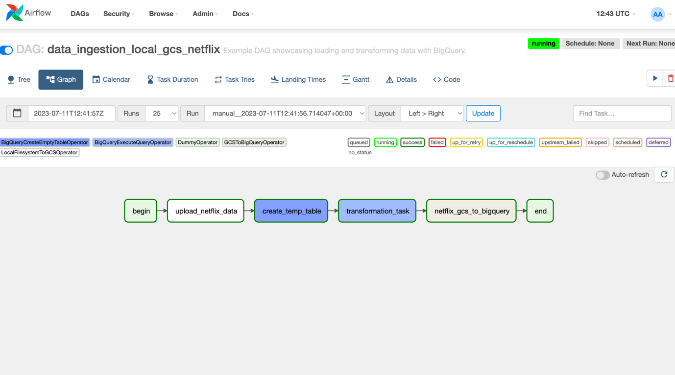

* Go to Google Cloud➔ Cloud Storage➔ Bucket➔ netflix-bucket ➔ netflix
* Make sure the **netflixData.csv** exist. 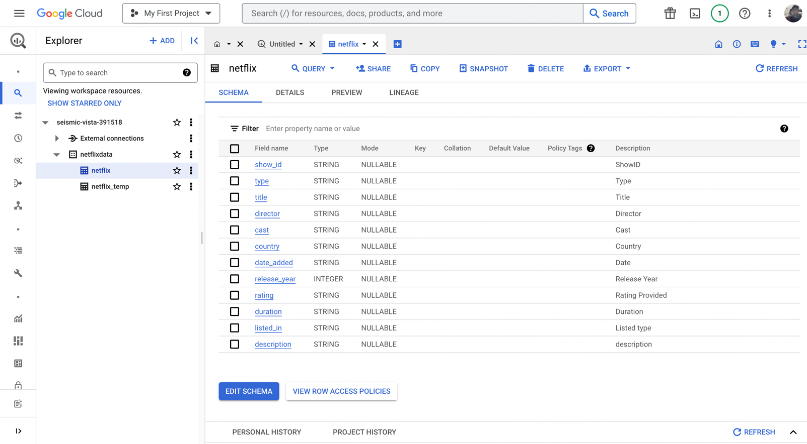

Open Looker Studio and import this dataset

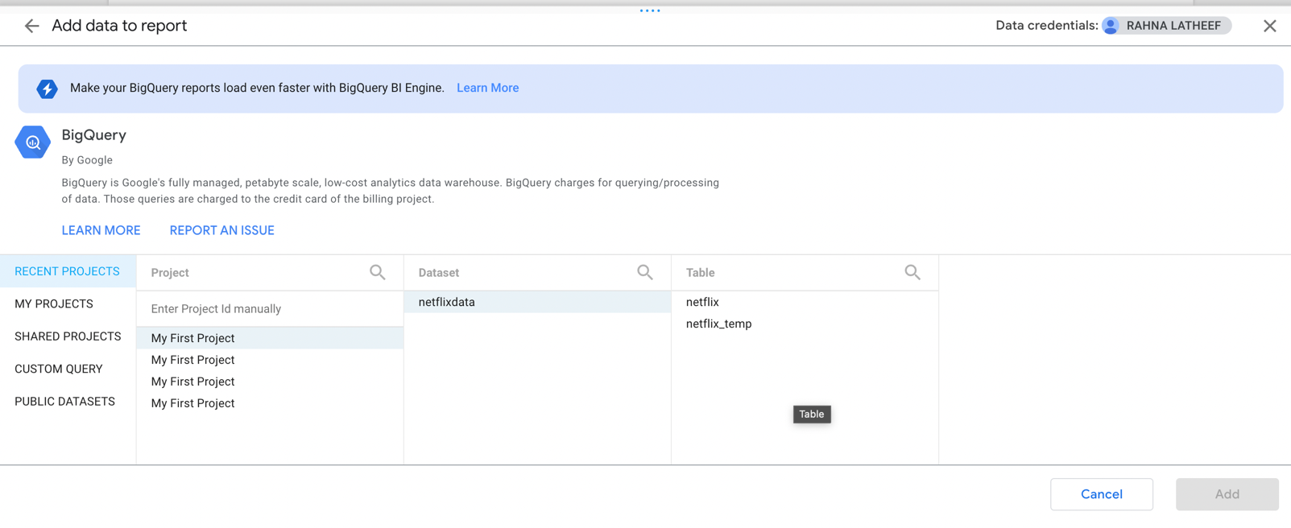

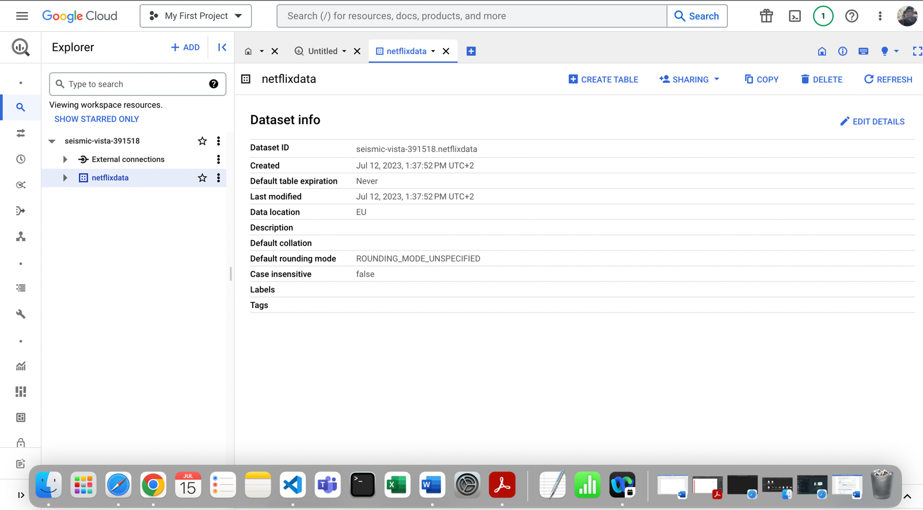

Create the Dashboard for both categorical and temporal data line data